GDD Template Introduction

This document attempts to provide a template/example of a typical Games Design Document (GDD). There is no such thing as a standard GDD format, every game will have different requirements for the contents of a GDD.

This template will need to be changed to suit the requirements of your game; some sections won't be necessary for your game and new sections may need to be added.

All the *italic text* in this document are sample descriptions taken from real world GDDs, as such, ALL the *italic text* should be removed and replaced with descriptions & details specific to your game. The explanatory footnotes should be removed also. Feel free to add your own footnotes.

This document is adapted from the [excellent GDD article](http://code.tutsplus.com/articles/effectively-organize-your-games-development-with-a-game-design-document--active-10140) by Gamux. I would strongly recommend reading that article before putting together your game design.

Avoid large blocks of text where possible, see [this article](http://gamasutra.com/blogs/ErinRobinson/20120502/169588/5_Alternatives_to_a_Game_Design_Doc.php) for ideas to communicate without text.

We’ve also put together a [small collection](https://drive.google.com/folderview?id=0B53oHWKOOjAEa1VuVmYzT1o4QUk&usp=sharing) of GDD from real world games. It would be worthwhile studying these.

B.Sc Computer Games Development, Year 4, Final Year Project

Game Design Document

**“<GAME_NAME>”**

Author: Alexander Meuer

Project Supervisor: Ross Palmer

# 

Table of contents

Overview

The Elevator Pitch / High Concept

Theme, Setting and Genre

Core aesthetics

Look and feel

View

Game flow summary

Experience duration

Target Audience

Key Features

Influences

What sets this project apart?

Targeted platform(s)

Technical requirements(s

GamePlay

The First Minute (60 seconds of play)

Game progression

Level progression

Objectives/Victory Conditions

Mechanics

Movement

Actions

Combat

Economy

**Sprint 1 Features**

Game World

Game geography

Game World Elements; Pieces/Enemies/Characters/Items/Spells [Game dependant]

Enemies

Towers

Spells/Abilities/Skills

Levels

Level description

Interface

Controls

In game overlays & dialogs

HUD

Screenflow

Control system

AI

Opponent AI

Support AI

Game Art & Audio

Visual aesthetics

Audio

Art assets

Characters/ animation frames

Items (in-game & icons)

level backgrounds/maps/environment textures

Visual effects

explosions

particles

HUD graphics, typeface

Controls screen/menu/dialog backgrounds/borders/typefaces

# 

# 

# Overview

### The Elevator Pitch / High Concept

<GAME_NAME> is a two-dimensional tower defence game that incorporates moba elements.

### Theme, Setting and Genre

The game will have a roman fantasy setting. It is a tower defence game with a controllable hero.

### 

### Core aesthetics

1. Fantasy *(play a role you can’t in real life)*
   * Take up the mantle of hero and save the <GAME_NAME>.
2. Challenge *(overcoming obstacles)*
   * Defeat wave after wave of enemies and take on strategically engaging boss fights.
3. Competition *(beating others, showing superiority, showing off)*
   * Compare scores and times with friend and foe worldwide via online leaderboards.

### Look and feel

The game will have a slightly cartoonish feel similar to Binding of Isaac or Kingdom Rush and will reflect it’s roman and mythological setting.

### View

The game will have an angled camera similar to that of League of Legends. It will be zoomable, pannable and lockable to the hero character.

### 

### Game flow summary

The player controls a hero character who has an array of skills, one of which being the ability to build various towers on the landscape. The player spends gold, gained from enemies, to build towers and purchase their respective upgrades. Each level is comprised of several waves, which get increasingly difficult. The player must use clever strategy to defeat each wave and win the level to proceed. Each level is plotted as a journey across an overworld map that will lead the player on their adventure.

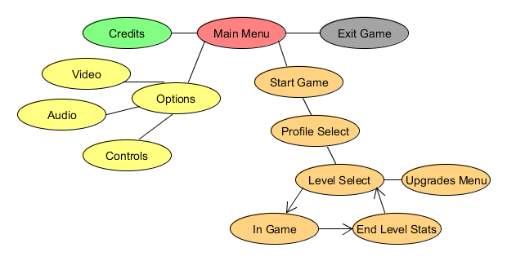

### Experience duration

Each level will take between 5 and 15 minutes, though some harder or end-game levels may go on longer. Experienced players may complete levels faster by calling waves early and playing exceptionally.

### 

### Target Audience

<GAME_NAME> will appeal to male gamers of ages 15 - 25 who typically play MOBA and RTS titles. In particular, fans of myth or fantasy themed media will be immediately attracted to <GAME_NAME>’s setting and aesthetic.

### Key Features

* Wave based levels with unrestricted tower placement options.
* Upgradeable hero character directly controlled by the player.
* Per-level upgrade trees for placed towers.
* Simple and vibrant art style with a limited palette.
* Compare scores and times with friends via online leaderboards.

### Influences

* Kingdom Rush
  + Flash Game
  + Most well known tower defence game on the internet. A good example of a great tower defence game.
* Giants and Dwarves Tower Defence
  + Flash Game
  + Side-scrolling tower defence game with a controllable hero.
* League Of Legends
  + PC/Mac Game
  + Most well known and most played MOBA game in the world. Easy to learn and difficult to master, it is a great example of controllable champions with skills.
* Roman/Greek mythology
  + Gods, titans, chimeras, hydras, minotaurs, centaurs. Mythology at it’s finest.

### What sets this project apart?

Tower Defence games have been around a long time and MOBA games are only now coming into their prime. I’m surprised I couldn’t find a game that combines these two genres already. I want to give the tower defence genre a new twist without rehashing an idea that’s been done to death.

### Targeted platform(s)

Windows.

### Technical requirements(s

The game will be programmed in C++ with help from the SFML, THOR and Boost libraries. I also plan on utilizing ChaiScript due to it’s ease of use and versatility.

# GamePlay

### The First Minute (60 seconds of play)

After the title screen the player is presented with the main menu. From there, they select New Game and are shown a map with the first level highlighted. From here they can decide to look at hero upgrades, select a level to play, or return to the menu. Upon selecting the first level the map transitions to the level screen. The player’s hero is alone on the landscape of the level (if they die, they will respawn after a delay); the player can click on the ground to have the hero move there. With their starting gold, the player builds an archer tower and a barracks and hits the Start Wave button on the edge of the screen.

The first wave of enemies pour into the level from one end, trying to make their way to the exit. The archer tower take it upon itself to kill a few enemies while the friendly minions deployed by the barracks hold enemies in place. The player hits a key for one of their abilities, *Cleave*, and lays out a few minions with a broad sweep of his sword(knocking enemies back). One enemy makes it through to the end and the player loses a life. They keep building towers with the gold collected from dead enemies and defeat all the level’s waves.

The player is shown a congratulatory end level screen with the time it took them to complete the level and is awarded two stars out of three because one enemy made it through their defences. They are returned to the overworld map.

## Game progression

* + 1. How do I progress from level to level?

At the end of each level the player is returned to the map where the next level will available to play. If the player loses a level, the next level will not be available.

* + 1. How does the game increase in difficulty?

Each consecutive level features harder waves. New enemies are introduced every few levels.

* + 1. What rewards (useful or not) are revealed to keep player engaged?

The player unlocks new hero and tower upgrades as they complete levels. These upgrades are more powerful the further along the upgrade tree they are.

## Level progression

* 1. How do I complete each level? I.e what are the objectives

Prevent enemies from reaching the level exit. Easier said than done as the game will throw various combinations of enemies at the player specifically designed to make each level challenging and strategically engaging for the player.

## Objectives/Victory Conditions

Every level must be completed for the game to consider itself finished. In each level, the player starts with 10 lives and loses one for each enemy that makes it through the level; if the hero dies, they will respawn after a delay. The player may return to any level as many times as they like and try to attain the three star rating for that level in order to achieve 100% game completion.

# Mechanics

### Movement

The player right clicks on the ground to move to that location. Their hero character will path across the level to that location, avoiding any rivers, cliffs, towers or otherwise impassable terrain on the way. They will take the most direct route to the location. A unit’s movement speed determines how fast it moves.

### Actions

The player can press a corresponding button to use a skill or activate tower placement. They can click to place valid towers and to move or attack. They can also select towers with a click and click on an upgrade to buy it.

### Combat

Every unit in the game has a number of combat stats in with varying values: health, armour, magic resistance, attack damage, attack speed. Ranged units will also have a attack range stat.

When a unit has no health left it is considered dead. Armour and magic resistance negate a portion of physical or magical damage respectively. When two melee unit’s make contact they will begin dealing their attack damage to each other, factoring in attack speed and armour. Multiple attackers can gang up on a single defending unit; in this case, all attackers are dealing damage to the lone defender, but the defender is retaliating only to whoever attacked it first. Some units or abilities may deal splash or area-of-effect(AoE) damage, which can hit many enemies at once.

The player can right click on an enemy to start attacking it and may press any of their skill hotkeys to use that skill on the enemy.

### Economy

The game awards up to three stars for successful completion of the level and these stars reflect how well the player fared. Stars are used to upgrade the hero characters and can be refunded at no cost.

The game awards gold for killing enemies; more difficult enemies drop more gold. Gold is not kept after a level but is used during the level to place and upgrade towers.

# Sprint 1 Features

* I can move the hero character around the level by clicking on where I wish to move to, thus allowing me to strategically position myself.
* I can attack enemies with the hero character by clicking on the enemy I wish to attack in order to prevent them from getting through my defences.
* I can place an archer tower on the level to attack any advancing enemies, preventing them from reaching the end.

I consider the three features above to be the minimum shippable product. The following features are also goals for the first sprint, however, they will be given less priority than the above features.

* I can place a unit producing building on the level, which will produce friendly units that will fight and block enemies from advancing.
* I can press a key to activate my hero’s Cleave ability, knocking back enemies and dealing more damage than a normal attack.
* I can place a magic tower on the level, which, like the archer tower, will attack advancing enemies. It will deal magic damage and is perfect for countering armoured enemies.

# 

# 

# Game World

### Game geography

*Areas, including the general description and physical characteristics as well as how it relates to the rest of the world (what levels use it, how it connects to other areas)*

### Game World Elements; Pieces/Enemies/Characters/Items/Spells[1] [Game dependant]

Should create a table of each type of game element (e.g. enemy list, item list). Each line in the table should include the following information about the element (where relevant)

* name
* description & appearance
* backstory synopsis or relationship to other elements (if important)
* abilities
* cost
* strength
* privileges

### Enemies

|  |  |  |
| --- | --- | --- |
| NAME | DESCRIPTION | FLAVOUR TEXT |
| Shade | The weakest, most basic enemy in the game. These will show up en masse and can overwhelm in numbers. | *Shadows of their former selves, these soldiers march single mindedly under a new general.* |
| Centuri-off | Wearing a little armour and hitting a little harder. These guys are the bigger cousins on the Shade enemy. Use magic to take them down quickly. |  |
| Sagittaurus | Minotaur wielding huge crossbows. Slow moving with a lot of health. |  |
|  |  |  |

### **Towers**

* 1. **Archer Towers**
     1. Basic Archer Tower

Fires arrows at enemies within range. Cheapest tower in the game. Can be upgraded to improve range, damage and attack speed.

* + 1. Ballista Tower
  1. **MagicTowers**
     1. Basic Mage Tower

Slower fire rate than archer tower. More expensive, more damaging and ignores armour.

* + 1. Terror Tower

Stores up to three attacks at a time. Slows enemies with a chance to fear.

* + 1. Necromancy Tower

Units killed by this tower are raised as skeletons under control of this tower. Additionally, units that die in an aura around the tower also have a chance to be raised.

* 1. **Artillery Towers**
     1. Basic Artillery Towers

Slow fire rate, splash damage, friendly fire

* + 1. Fire Tower

Ignites enemies to deal damage over time.

* + 1. Morter

More damage than basic artillery. Knocks back units.

.

* 1. **Unit Producing Towers**
     1. Field Tent

The basic unit producing tower. Produces friendly units that block the path for oncoming enemies. A meat-shield so that towers can get more hits in.

* + 1. Barracks

Trains Legionnaires. High armour, can take a beating and give it back.

* + 1. Arena

Trains expendable and quickly replaced units. High damage, low health. A little magic resist also.

### **Spells/Abilities/Skills**

|  |  |
| --- | --- |
| NAME | EFFECT |
| We Are Legion | *Passive*. A group of Legionnaires follow the hero wherever he goes. They will be replaced over time if they die. |
|  |  |

# 

# 

# 

# Levels

## Level description

Each level must be described;

* Introductory material (is the player given any hints, back-story or goals prior to starting level)
* What are objectives
* What additional skills are needed
* Level map & critical path
* Important encounters
* what elements are available/unlocked in the level
* For training levels, what skills are developed

# Interface

### Controls[2]

Example

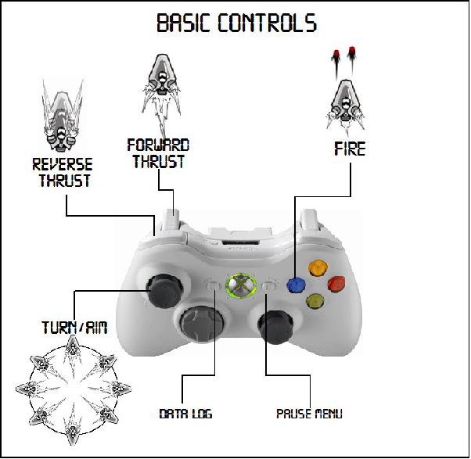

### In game overlays & dialogs

How does the player interact with complex ingame systems like tech tree, inventory, trade, communication. Show mock up dialog boxes and be explicit about how the player activates, navigates and dismissed these.

### HUD

Diagram of the HUD, clearly showing what info is available

### Screenflow[3]

A graphical description of how each screen is related to every other and a description of the purpose of each screen.

*Example:*

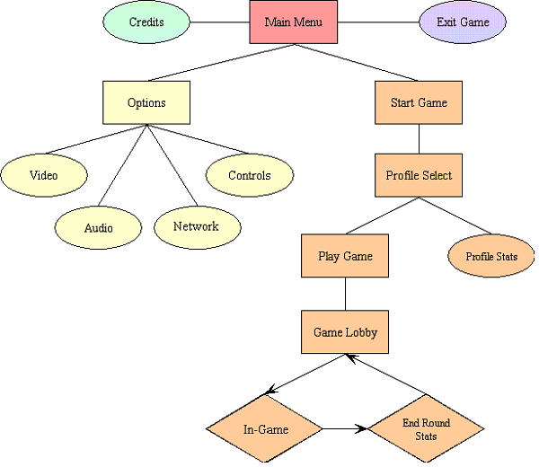

Wrong (diagram below) *(Nothing THIS simple. Include, at least, all the screens that the player will run through!)*

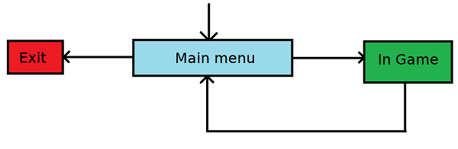

## Control system

How does the player control things like open/save game, network lobbies, custom controls. Show mock-up screenshots for these.

# AI[4]

## Opponent AI

What strategic decisions do the NPCs need to make in order to defeat (or collaborate with the player.

## Support AI

Path finding for player character, giving player hints.

# Game Art & Audio

# Visual aesthetics

* + 1. What is the visual style of this game. How does the style reinforce the gameplay?

### Audio

* + 1. Background music
    2. Audio effects
    3. Dialog

### Art assets

##### Characters/ animation frames

##### Items (in-game & icons)

##### level backgrounds/maps/environment textures

##### Visual effects

##### explosions

##### particles

##### HUD graphics, typeface

##### Controls screen/menu/dialog backgrounds/borders/typefaces

1. Puzzles could have a “Pieces” subsection (e.g tetris), space shooters may have “Enemies” and so on. Other games may have other entity types, Weapons, Power-ups, Planets, Buildings
2. Describe how the player will initiate any of the actions available to him/her
3. This is a more detailed subsection of the Gameplay than the First Minutes. It’s a kind of flowchart that shows which reaction each option has, giving a picture of the game as a whole. Generally it shows a flow of screens (e.g. from the “Main menu” screen it goes to the “Select level” screen)
4. Any game will need a persisting world to handle all the player’s actions to the game and the other way around. That includes enemy movements, player controls, collision handling, time counting, random number generators and many other things one could need in a game. Although people not directly related to the programming may not understand this subsection entirely, they should at least grasp the basic of it. Most of all, keep the coding out of here and simply state the enemies' moving patterns, the chain puzzle piece falling algorithm, maybe illustrate the combat system with a flowchart and so on.